**Design of Inverting, Non Inverting amplifiers and Voltage follower**

**Exp No: 1 Date: 06/02/2021**

**Objective:**

To design, simulate and verify Inverting, Non-Inverting and Voltage Follower circuits.

**Software Required:**

LT SPICE - XVII

**Theory:**

**Inverting Operational Amplifier Configuration: -**

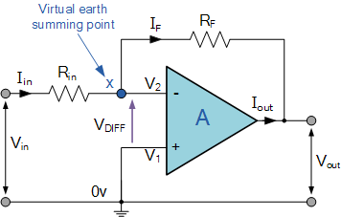

In this **Inverting Amplifier** circuit, the operational amplifier is connected with feedback to produce a closed loop operation. When dealing with operational amplifiers there are two very important rules to remember about inverting amplifiers, these are: “No current flows into the input terminal” and that “V1 always equals V2”. However, in real world op-amp circuits both of these rules are slightly broken.

This is because the junction of the input and feedback signal (X) is at the same potential as the positive (+) input which is at zero volts or ground then, the junction is a “Virtual Earth”. Because of this virtual earth node, the input resistance of the amplifier is equal to the value of the input resistor, Rin and the closed loop gain of the inverting amplifier can be set by the ratio of the two external resistors.

Then, the Closed-Loop Voltage Gain of an Inverting Amplifier is given as: -

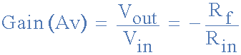

and this can be transposed to give VOUT as: -

inverting operational amplifier gain

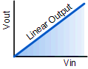

**Linear Output: -**

The negative sign in the equation indicates an inversion of the output signal with respect to the input as it is 180o out of phase. This is due to the feedback being negative in value.

The equation for the output voltage VOUT also shows that the circuit is linear in nature for a fixed amplifier gain as VOUT = VIN x Gain. This property can be very useful for converting a smaller sensor signal to a much larger voltage.

**Non-Inverting Amplifiers: -**

Non-inverting op amps work following the op amp golden rules:

The Current Rule: No current flows into the inputs of the op amp (I+=I-=0).

The Voltage Rule: The output of the op amp attempts to ensure that the voltage difference between the two inputs is zero (V+=V-).

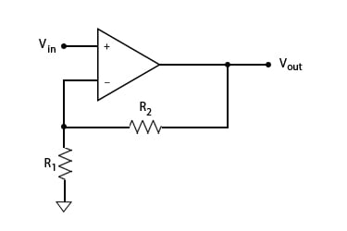

Consider the non-inverting op amp circuit shown above. According to the Voltage Rule, the voltage at the inverting (-) input will be the same as at the non-inverting (+) input, which is the applied voltage VIN.

The current going through R1 can then be given as VIN/R1.

According to the Current Rule, the inputs draw no current, so all that current must then flow through R2.

The output voltage can then be given as VOUT=VIN+(VIN/R1)R2.

The gain is then VOUT/VIN=1+(R2/R1).

The gain will never be less than 1, so the non-inverting op amp will produce an amplified signal that is in phase with the input.

**Voltage Follower: -**

A voltage follower (also known as a buffer amplifier, unity-gain amplifier, or isolation amplifier) is an [op-amp](https://www.electrical4u.com/op-amp-working-principle-of-op-amp/) circuit whose output [voltage](https://www.electrical4u.com/voltage-or-electric-potential-difference/) is equal to the input voltage (it “follows” the input voltage). Hence a voltage follower op-amp does not amplify the input signal and has a voltage gain of 1.

The voltage follower provides no attenuation or amplification—only buffering.

A voltage follower circuit has a very high input impedance. This characteristic makes it a popular choice in many different types of circuits that require isolation between the input and output signal.

The circuit of voltage follower is shown below.

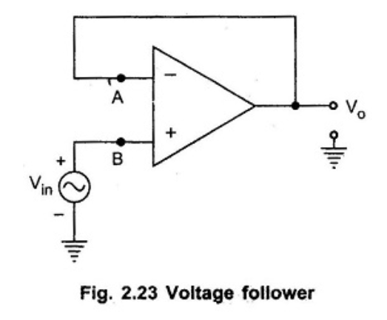

An important law that underpins a voltage follower is [Ohm’s law](https://www.electrical4u.com/ohms-law-equation-formula-and-limitation-of-ohms-law/).

Which states that a circuit’s [current](https://www.electrical4u.com/electric-current-and-theory-of-electricity/) is equal to its [voltage](https://www.electrical4u.com/voltage-or-electric-potential-difference/) divided by its [resistance](https://www.electrical4u.com/what-is-electrical-resistance/).  
As mentioned, voltage followers have a very high input impedance.

But before we discuss circuits with high impedance, it will be helpful to first understand what goes on in a circuit with a low impedance.

A low input impedance - and hence resistance in this case - will result in the “R” in the formula for Ohm’s law being small.

With a fixed voltage (V), this will mean that a large amount of current will be drawn by a low-impedance (Resistance) load.

**Procedure: -**

* **Open LT Spice and click on new schematic to start the circuit making.**
* **Components needed are: wires, ground, resistor, op-amp and voltage sources.**
* **Place them all in the required way as per the requirement of circuit analysis.**
* **Perform required analysis like transient or ac analysis etc.**
* **Run the schematic once the circuit is complete**
* **Click above the ac input voltage source for the input signal**
* **Click above the load resistor to obtain the output signal.**
* **Analyse the input and output obtained from the circuit analysis on LT Spice.**
* **Save the schematic and continue further analysis if required.**

**Inverting Amplifier: -**

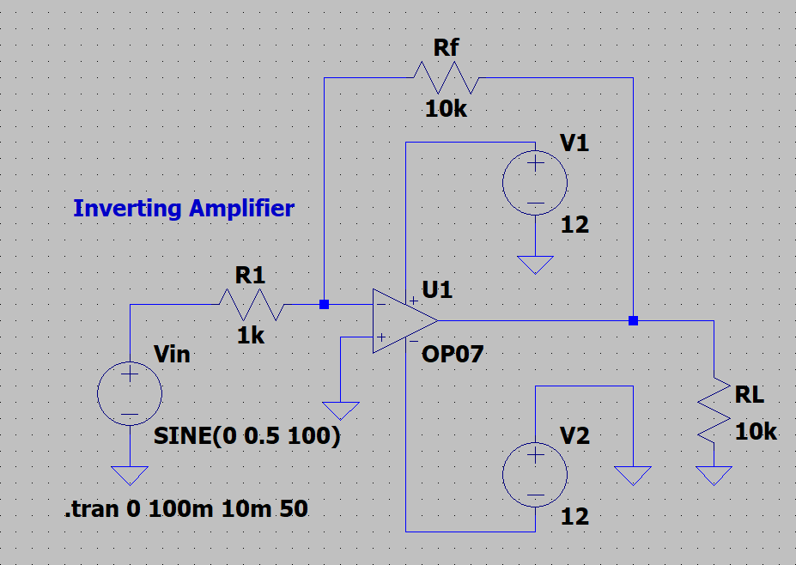

Input:

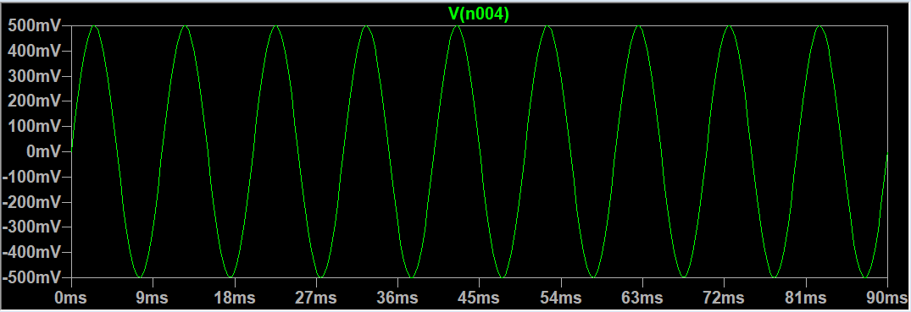

Output:

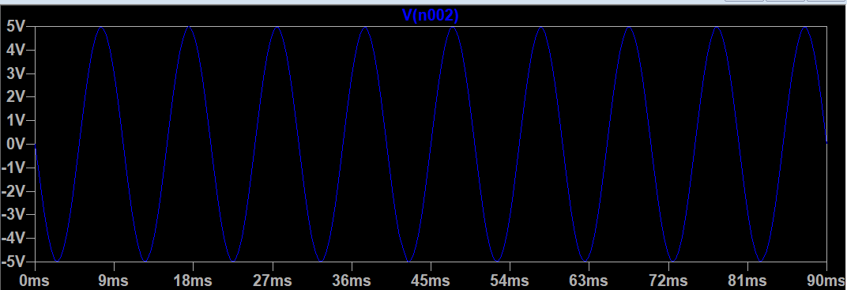

Comparison: (OUT OF PHASE)

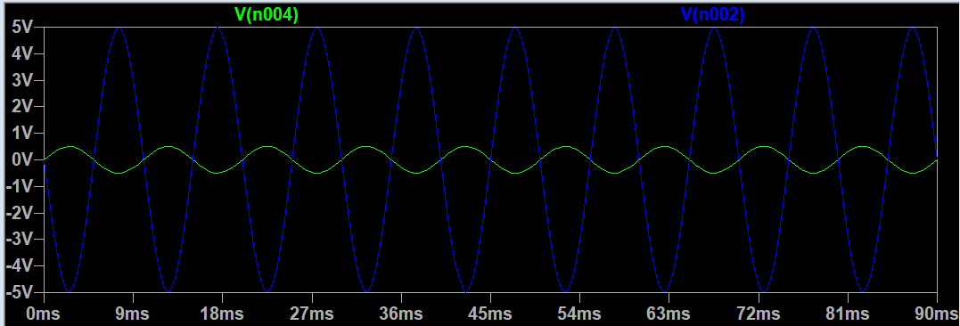

Calculations:

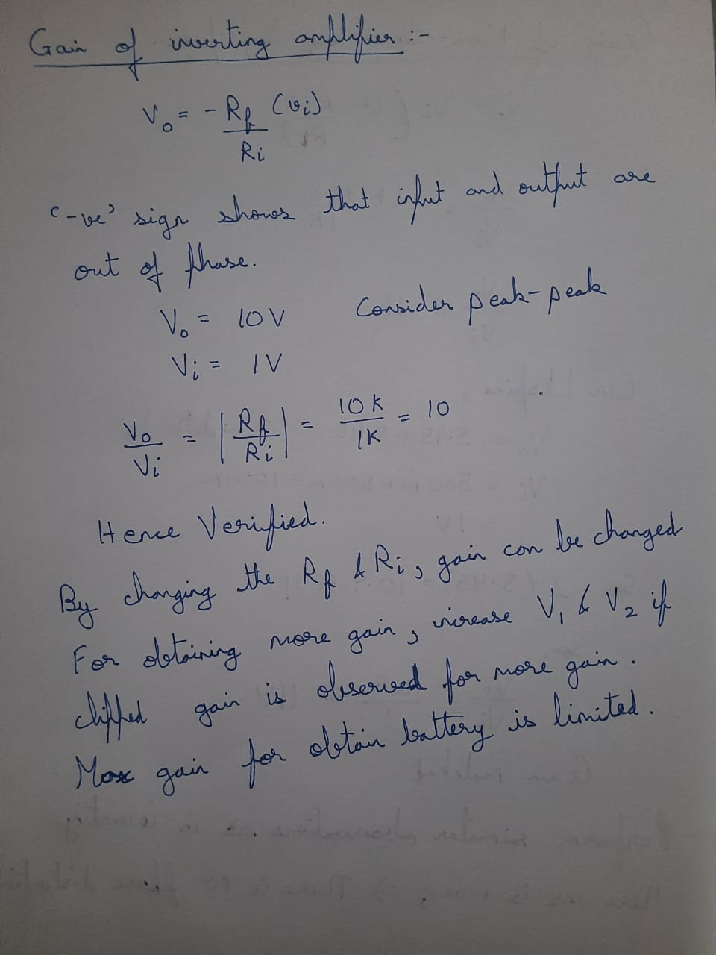

Extra Observations: -

For V1 = 0:

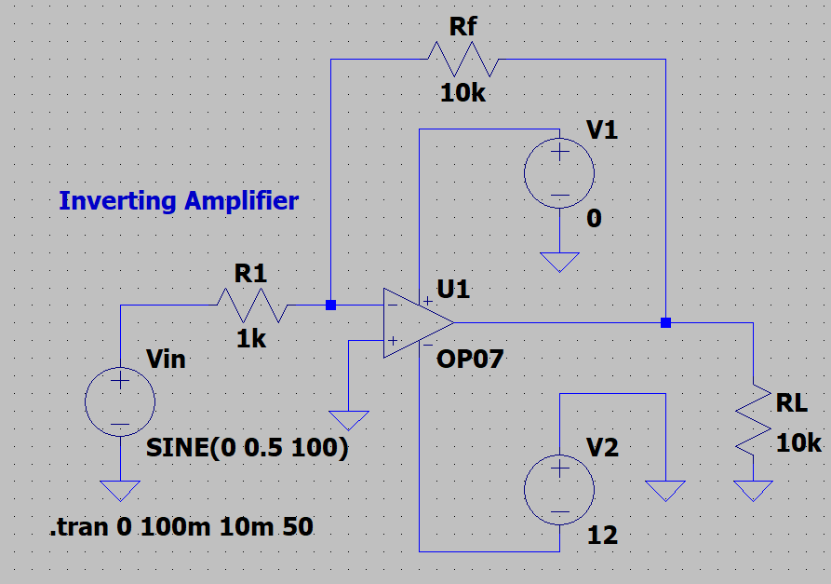

Output and Input Analysis: - (POSITIVE CLIPPED)

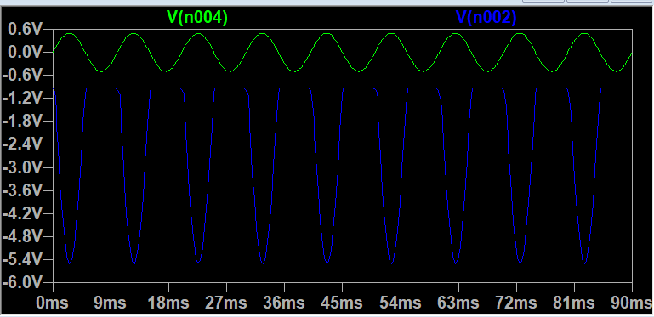

FOR V2=0:

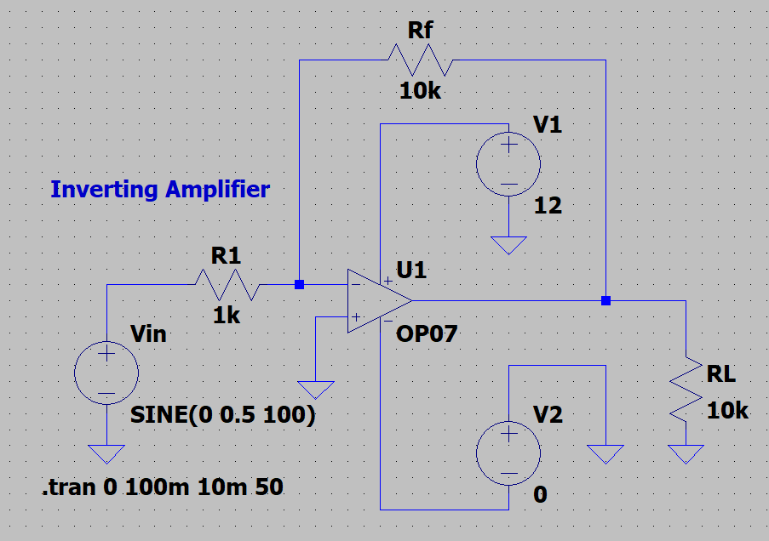

Output and Input Analysis: - (NEGATIVE CLIPPED)

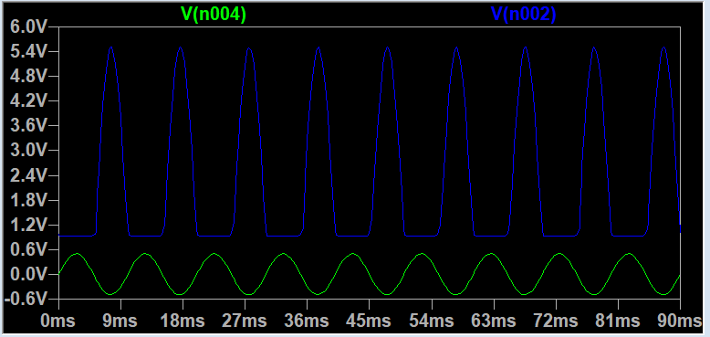

Maximum Gain obtained for batteries - 12 volts:

To check this lets, design a circuit to obtain 50 gains. By formula we know that Rf/R1 = 50 that means Rf = 50k and R1 = 1k

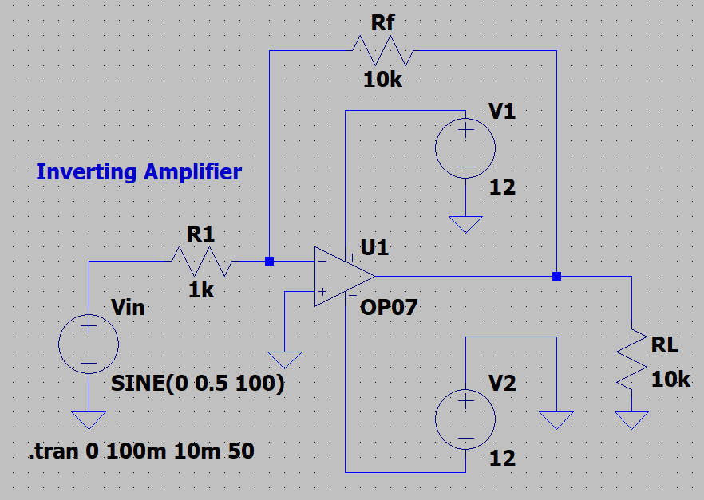

Output and Input Observation: -

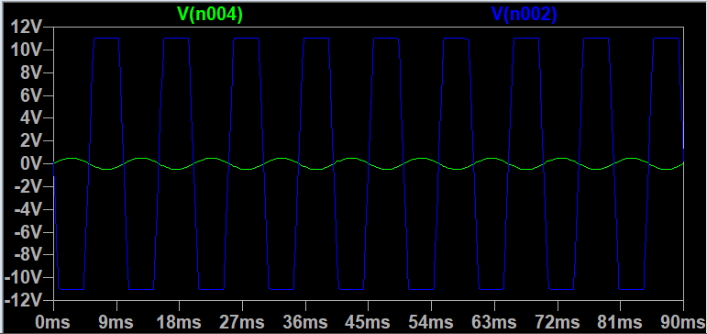

So, the Max Gain for 12 Volt batteries is 22/1 = 22. So, to obtain 50 as gain as 50 we need to increase the battery voltage.

===========================================================================

Inverting Amplifier:

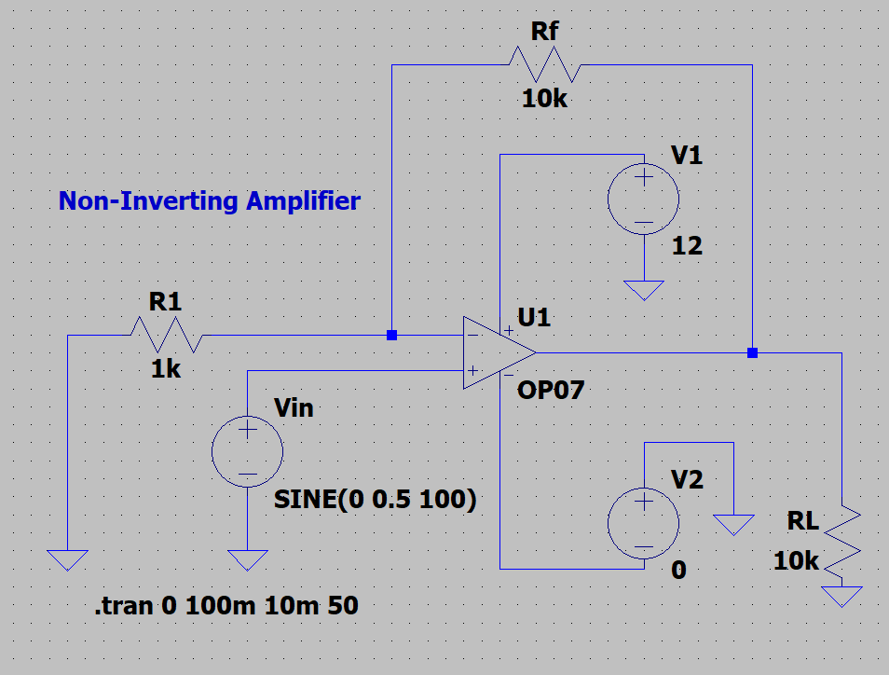

Input:

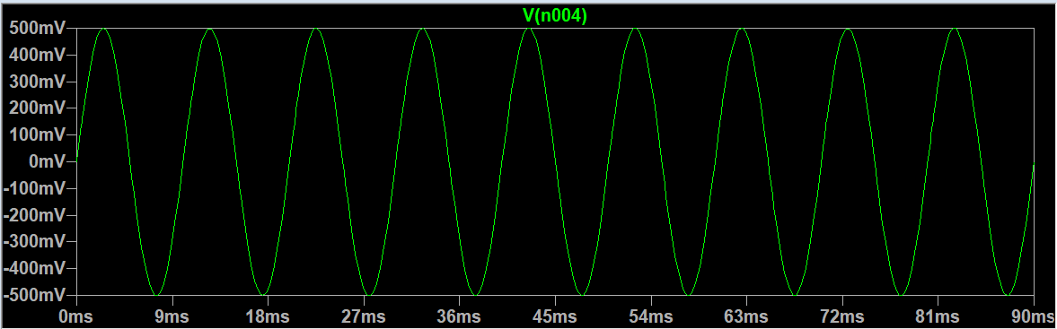

Output:

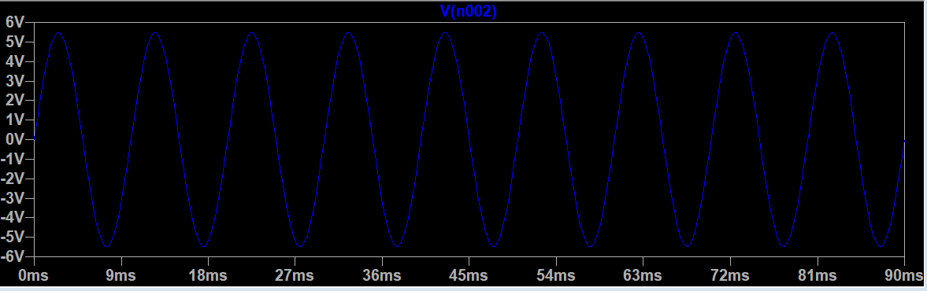

Comparison: (IN PHASE)

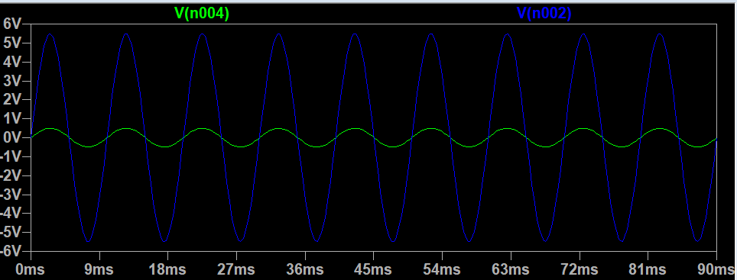

Calculations:

-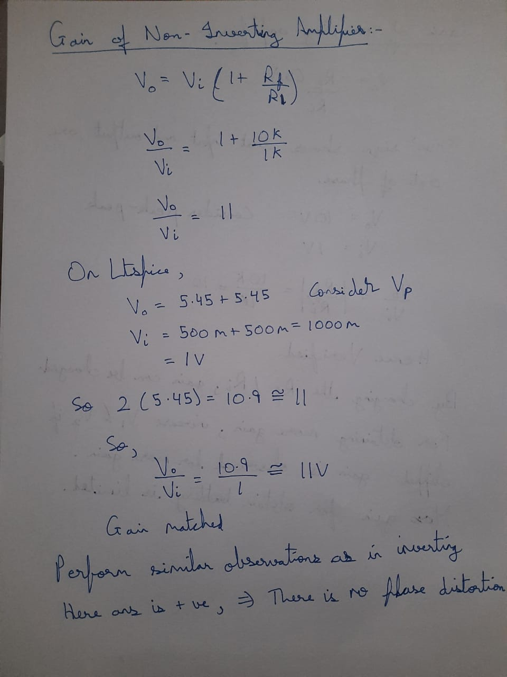

Voltage Follower: -

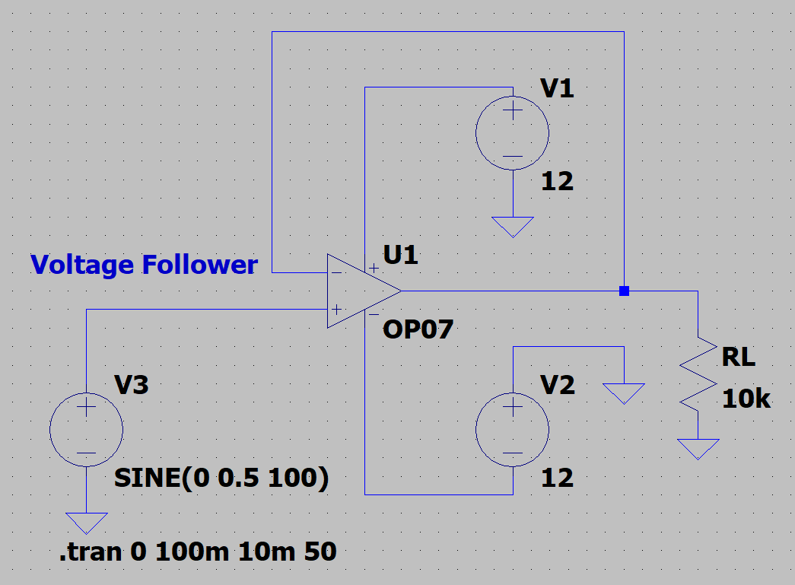

Input:

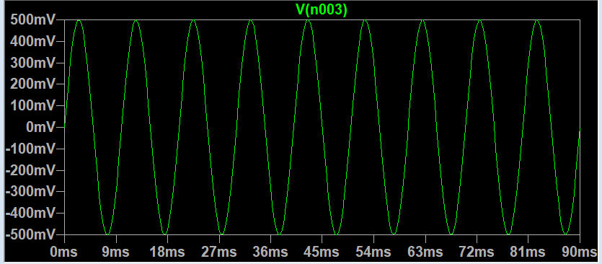

Output:

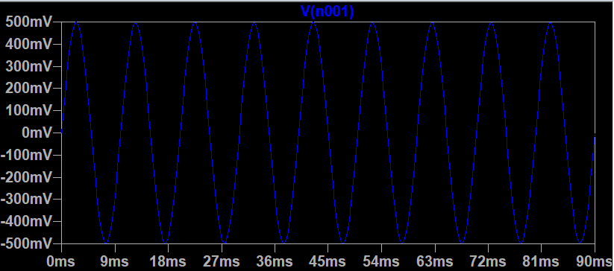

Comparison: - (BOTH INPUT AND OUTPUT ARE SAME)

The Gain = Unity

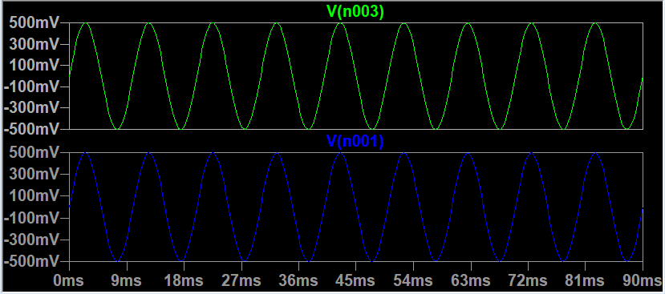

**RESULT:**

Thus, the inverting, non-inverting amplifiers and voltage followers are designed, tested and verified using LTSPICE.